**Resistors and LEDs Parallel Configurations**

This document is to discuss whether to choose:

1. One resistor for each LED in parallel branch.
2. One bigger resistor for the whole LEDs.

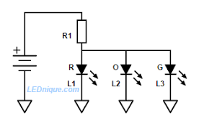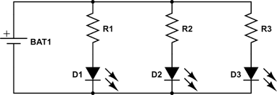

**Figure 1**

**Figure 2**

|  |  |
| --- | --- |
| **Choice 1** | **Choice 2** |
| * This choice remove the headache of lower voltage on each branch and also will protect the other LEDs if one of them were to be burnt. * It has more complicated routing and space on the PCB. Also, it is higher in cost. | * It has the advantage of smaller circuit and easier routings. Also, it is cheaper due to its less components than choice 1. * Its disadvantage is that if one of the LEDs has lower voltage drop due to different color or manufacturing errors, the lower voltage drop will be applied to the other LEDs causing lower luminous intensity in all of them. Also if one of the LEDs were to be burnt, the other LEDs will be burnt directly after it due to the current reached will be much higher than the limited current of the LED. |

**For reference**: <https://www.youtube.com/watch?v=5BoBNW3swpA>.